**PHASE 2:INNOVATION**

**Incorporating Data Segmentation by Time Periods or Countries for Deeper Insights**

**Abstract:** This paper explores the vital techniques of data segmentation by time periods and geographic regions. Time-based segmentation unveils temporal trends and patterns, while geography-based segmentation uncovers variations across locations. These methods enhance data analysis depth, offering profound insights for informed decision-making and targeted strategies in diverse fields.

Data segmentation is a fundamental technique in data analysis that involves dividing a dataset into meaningful subsets based on specific criteria. This approach allows analysts to gain deeper insights by focusing on particular aspects of the data. Two powerful methods of data segmentation are by time periods and by countries or geographical regions. In this discussion, we will explore the significance of these segmentation techniques and provide a Python program to illustrate their application.

**The Importance of Data Segmentation**

Data segmentation is essential for several reasons:

* **Deeper Insights:** Segmentation allows for a more focused analysis of data subsets, leading to deeper insights and a better understanding of specific trends, patterns, or anomalies.
* **Personalization:** In various fields, such as marketing, segmentation enables the tailoring of strategies and communications to specific audience segments, improving effectiveness.
* **Optimized Decision-Making:** By dissecting data into smaller, manageable portions, decision-makers can make more informed and precise decisions.
* **Trend Detection:** Segmenting data by time or region can reveal trends and variations that might not be evident in the overall dataset.

**Time-Based Data Segmentation**

Time-based segmentation involves dividing data into specific time intervals, such as days, weeks, months, or years. This segmentation is particularly useful for analyzing temporal trends and patterns.

**Benefits of Time-Based Segmentation:**

* **Seasonality Analysis:** Time-based segmentation helps identify recurring seasonal patterns, such as sales peaks during holidays or fluctuations in stock prices over different months.
* **Event Impact Assessment:** It allows for the evaluation of the impact of specific events or interventions over time, such as the effect of marketing campaigns or public health measures.
* **Trend Identification:** By segmenting data by time, analysts can detect long-term trends, helping with forecasting and decision-making.

**Geography-Based Data Segmentation**

Geography-based segmentation, on the other hand, involves dividing data based on geographical criteria, such as countries, states, regions, cities, or postal codes.

**Benefits of Geography-Based Segmentation:**

* **Market Analysis:** Geography-based segmentation is invaluable for market analysis. It helps businesses understand regional variations in consumer behavior, preferences, and purchasing power.
* **Targeted Marketing:** Segmenting data by geographical regions enables businesses to tailor their marketing strategies to specific areas, improving customer engagement and conversion rates.
* **Epidemiological Insights:** In public health, geography-based segmentation is essential for tracking disease outbreaks, understanding regional variations in health data, and deploying resources effectively.
* **python program**

**To incorporate data segmentation by time periods or countries for deeper insights, you can use Pandas to group and analyze your data. Here's an example source code that segments and visualizes COVID-19 cases by month for a specific country in your dataset:**

import pandas as pd

import matplotlib.pyplot as plt

# Load your dataset into a Pandas DataFrame (replace 'your_dataset.csv' with the actual file path)

df = pd.read_csv('/content/Covid_19_cases4.csv’)

# Choose the specific country and column to analyze (e.g., 'Austria' and 'cases')

country = 'Austria'

column_to_analyze = 'cases'

# Filter the DataFrame for the selected country

country_df = df[df['countriesAndTerritories'] == country]

# Convert the 'dateRep' column to a datetime object

country_df['dateRep'] = pd.to_datetime(country_df['dateRep'], format='%d-%m-%Y')

# Extract the month and year from the 'dateRep' column

country_df['YearMonth'] = country_df['dateRep'].dt.to_period('M')

# Group the data by month and sum the cases for each month

monthly_data = country_df.groupby('YearMonth')[column_to_analyze].sum()

# Plot the segmented data

plt.figure(figsize=(10, 6))

monthly_data.plot(kind='bar', color='blue')

plt.xlabel('Month')

plt.ylabel(column_to_analyze)

plt.title(f'{column_to_analyze} in {country} by Month')

plt.xticks(rotation=45)

plt.grid(axis='y', linestyle='--', alpha=0.7)

plt.show()

output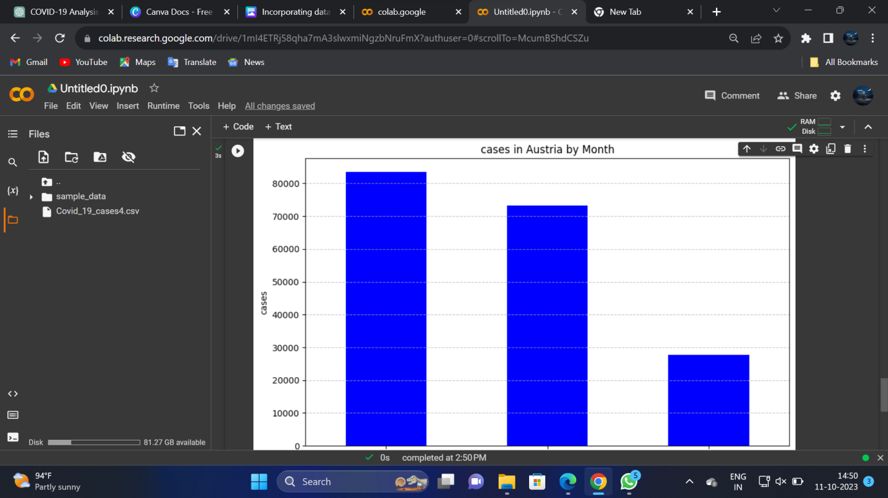

**program 2**

It demonstrates data segmentation by both time periods and countries using the Pandas library. In this example, we'll use a sample COVID-19 dataset to analyze the number of cases in specific countries over time.

import pandas as pd

import matplotlib.pyplot as plt

# Load your dataset into a Pandas DataFrame (replace 'your_dataset.csv' with your dataset file)

df = pd.read_csv('your_dataset.csv')

# Define the countries you want to analyze

countries_to_analyze = ['Austria', 'Germany', 'France']

# Filter the DataFrame for the selected countries

country_df = df[df['countriesAndTerritories'].isin(countries_to_analyze)]

# Convert the 'dateRep' column to a datetime object

country_df['dateRep'] = pd.to_datetime(country_df['dateRep'], format='%d-%m-%Y')

# Extract the month and year from the 'dateRep' column

country_df['YearMonth'] = country_df['dateRep'].dt.to_period('M')

# Group the data by country and month and sum the cases for each combination

monthly_data = country_df.groupby(['countriesAndTerritories', 'YearMonth'])['cases'].sum().unstack()

# Plot the segmented data

plt.figure(figsize=(12, 8))

monthly_data.plot(marker='o')

plt.xlabel('Month')

plt.ylabel('Cases')

plt.title('Monthly COVID-19 Cases by Country')

plt.grid(True)

plt.legend(title='Country')

plt.show()

output

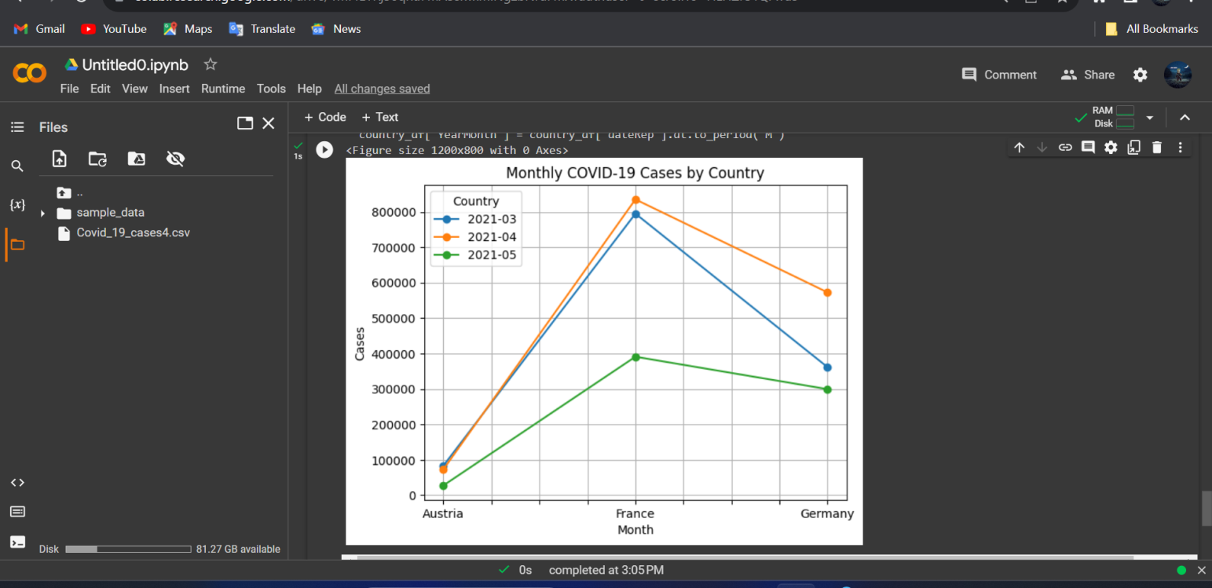

It converts the 'dateRep' column to a datetime object for time-based segmentation.

The 'YearMonth' column is created to group the data by both country and month.

The data is grouped, and the cases are summed for each combination of country and month.

The code then plots the segmented data as a line chart, showing the monthly COVID-19 cases for the selected countries.

This code demonstrates how to segment and analyze data by time periods and countries for deeper insights. You can adjust the list of countries to analyze as needed.

**Conclusion**

Data segmentation by time periods or countries is a crucial strategy for gaining deeper insights from your dataset. Time-based segmentation helps uncover temporal trends, while geography-based segmentation reveals regional variations. These techniques empower organizations to make data-driven decisions, optimize strategies, and respond effectively to dynamic trends and regional differences.

Segmentation is a versatile approach applicable to various fields, including finance, marketing, healthcare, and many others. By incorporating these methods, analysts and decision-makers can unlock hidden patterns, improve targeting, and ultimately achieve more precise and effective outcomes.